## DevOps Node.js Application - CI/CD Case Study Report

Submitted by - Pranjal.P.Shinde

### Table of Contents

1. Introduction
2. Project Structure
3. Node.js Application
4. Git & GitHub Workflow
5. Dockerization
6. Terraform Infrastructure Provisioning
7. Ansible for Configuration Management
8. Jenkins CI/CD Pipeline
9. Shell Scripts
10. Common Errors & Troubleshooting
11. Architecture Diagram
12. Final Report Summary

### 1. Introduction

This report presents a full DevOps implementation of a Node.js application using containerization, infrastructure as code, configuration management, and continuous integration/deployment (CI/CD). Technologies involved include Docker, Terraform, Ansible, Jenkins, and GitHub.

### 2. Project Structure

The project repository is structured as follows:

DevOps-NodeApp-Project/  
├── ansible/  
│ ├── deploy.yml  
│ └── hosts.ini  
├── infra/  
│ ├── main.tf  
│ ├── variables.tf  
│ ├── outputs.tf  
├── scripts/  
│ ├── build_and_push.sh  
│ └── cleanup.sh  
├── src/  
│ └── index.js  
├── Dockerfile  
├── Jenkinsfile  
├── REPORT.md  
└── README.md

Each directory or file serves a specific DevOps purpose, from provisioning infrastructure to deploying the app.

Flowchart🡪

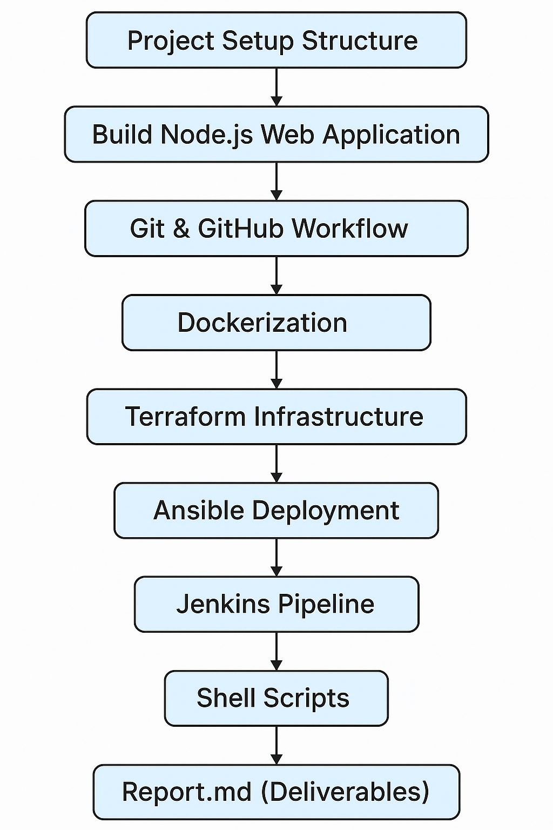

### 3. Node.js Application

### DevOps-NodeApp-Project/

### |🡪src/

### └── index.js

### |🡪package.json

### |🡪 package-lock.json (auto-generated)

### | 🡪README.md

npm install

npm start

### 4. Git & GitHub Workflow

* Branches: main, developer
* Pull requests: work on developer, PR to main

Commands 🡪

mkdir DevOps-NodeApp-Project

cd DevOps-NodeApp-Project

git init

git checkout -b main

git add .

git commit -m "Initial commit with enhanced Node.js app"

git remote add origin https://github.com/<your-username>/DevOps-NodeApp-Project.git

git push -u origin main

git checkout -b developer

git add src/index.js

git commit -m "Added new DevOps message from developer branch"

git push -u origin developer

git checkout main

git pull origin main

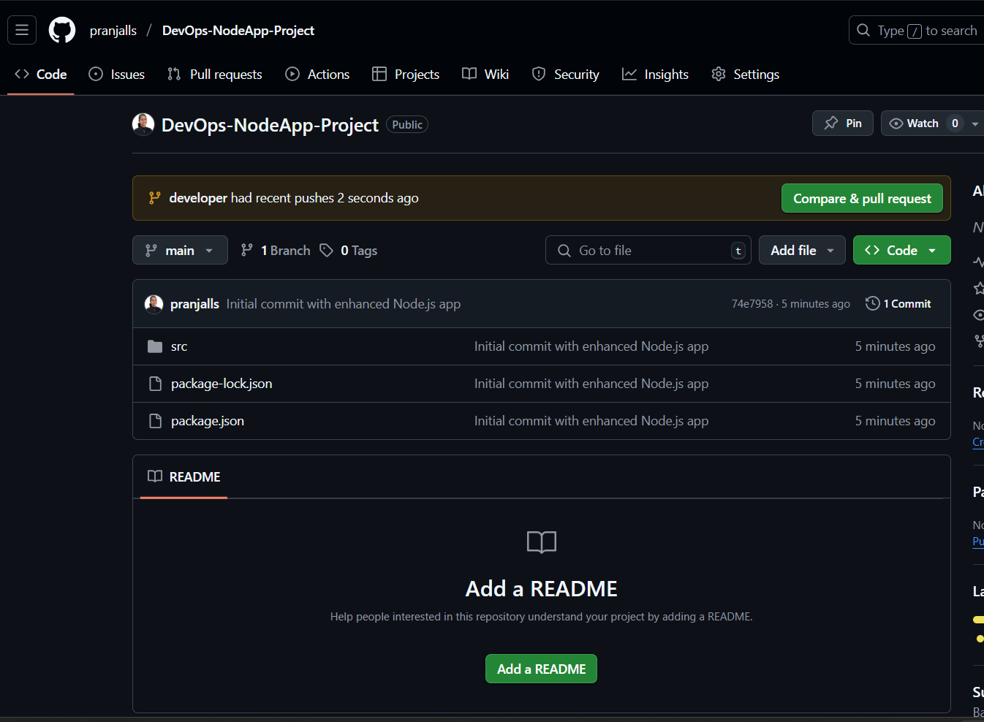

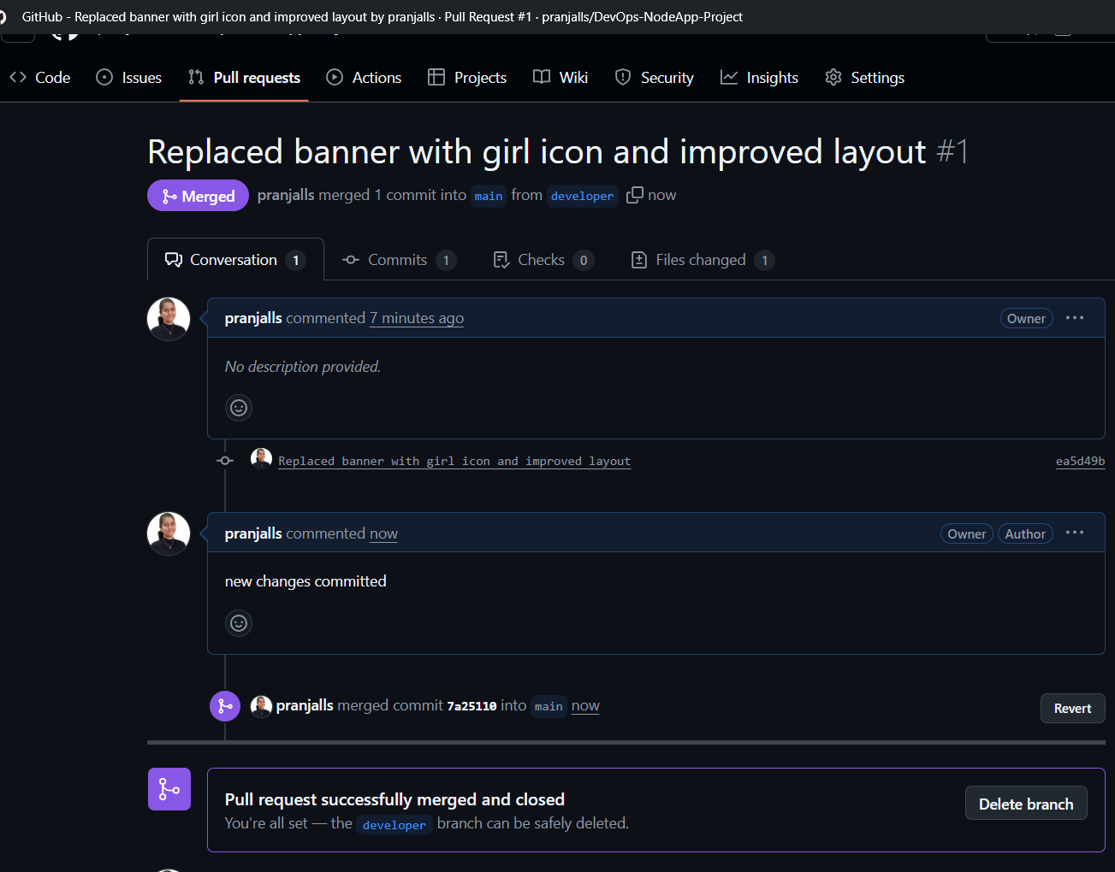

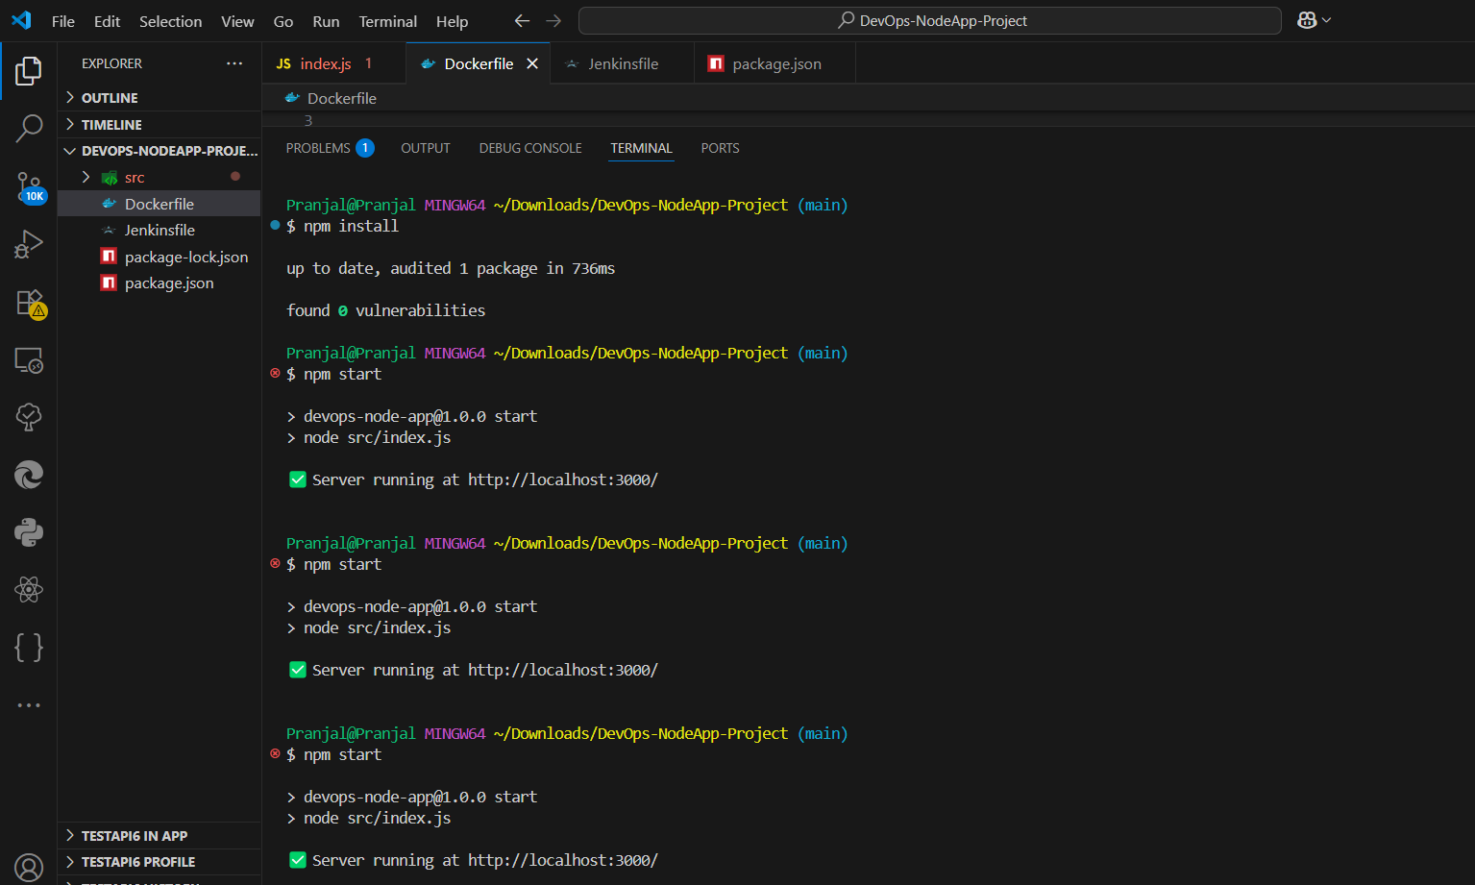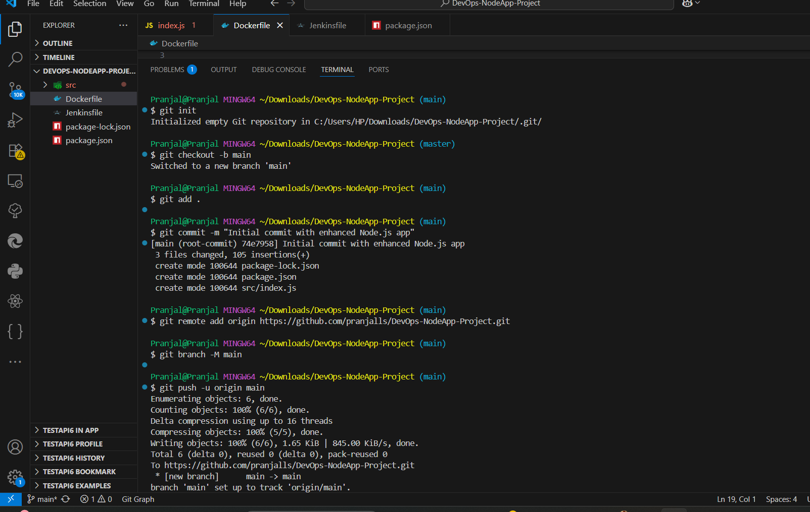

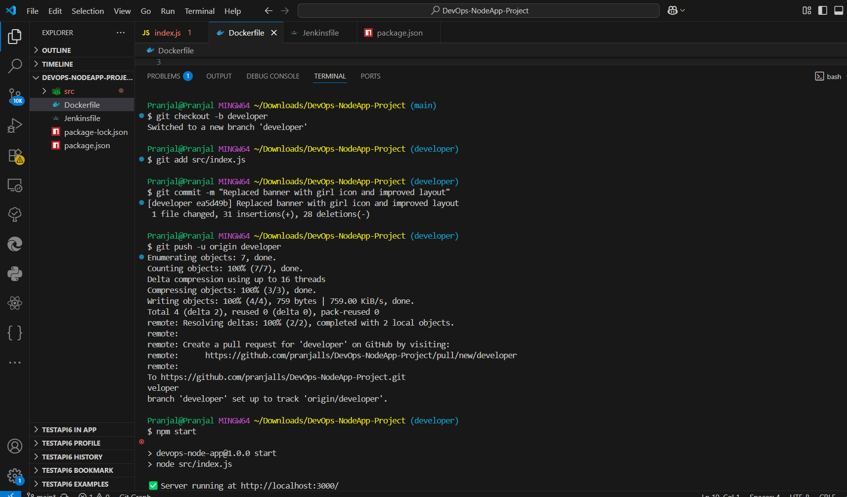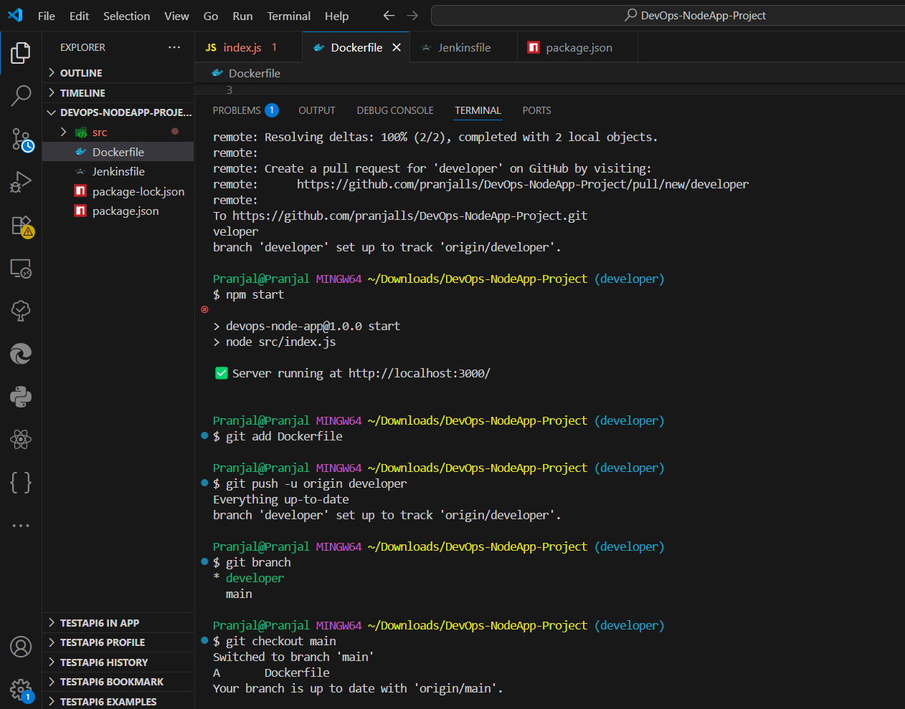

### 5. Dockerization

* Write a Dockerfile to containerize your Node.js app
* Build and tag the Docker image
* Push it to your DockerHub account using a script

**Dockerfile**

FROM node:18  
WORKDIR /usr/src/app  
COPY package*.json ./  
RUN npm install  
COPY . .  
EXPOSE 3000  
CMD ["npm", "start"]

**Script:** ``

#!/usr/bin/env bash

set -euo pipefail

# Set your DockerHub username

DOCKER_USERNAME="yourdockerhubusername"

# Get the latest Git commit short hash

GIT_COMMIT=$(git rev-parse --short HEAD)

# Image name and tag

IMAGE="$DOCKER_USERNAME/devops-node-app:$GIT_COMMIT"

echo "🔧 Building Docker image: $IMAGE"

docker build -t $IMAGE .

echo "🚀 Pushing Docker image to DockerHub..."

docker push $IMAGE

echo "✅ Done: $IMAGE"

**Run:**

docker login

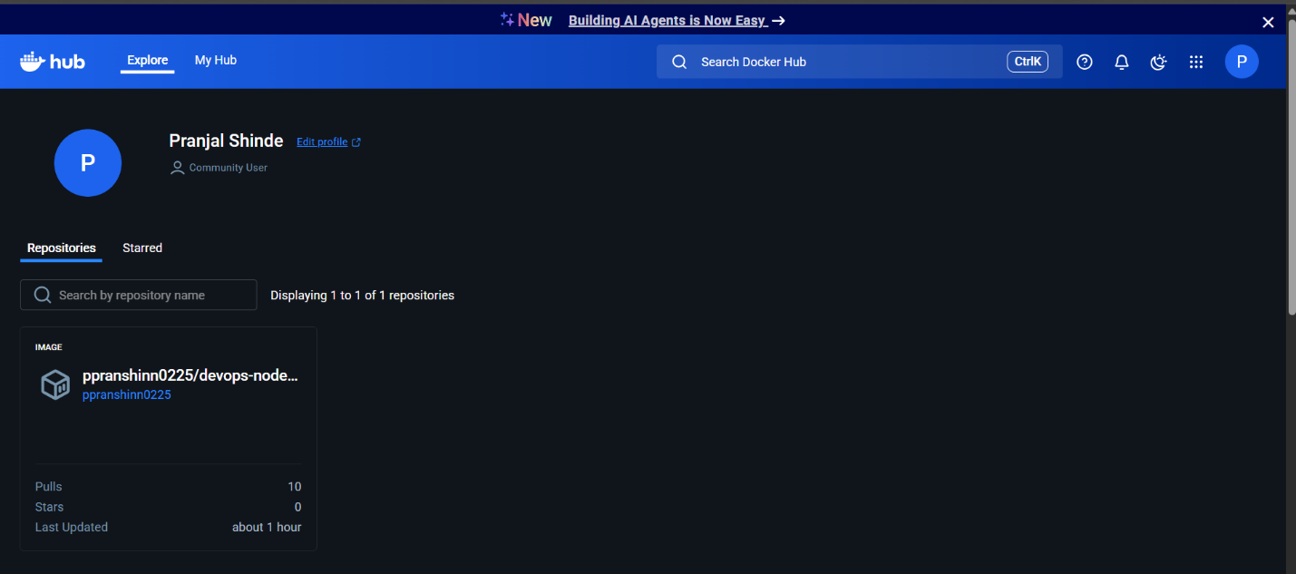chmod +x scripts/build_and_push.sh  
./scripts/build_and_push.sh

### 6. Terraform Infrastructure Provisioning

In infra/, write Terraform code to provision:

• A new VPC with one public subnet

• A t2.micro EC2 instance in that subnet

• A security group allowing SSH (22) and HTTP (80)

• An Elastic IP attached to the EC2 instance

DevOps-NodeApp-Project/

└── infra/

|── main.tf

|── variables.tf

|── outputs.tf

**Run:**

cd infra

terraform init

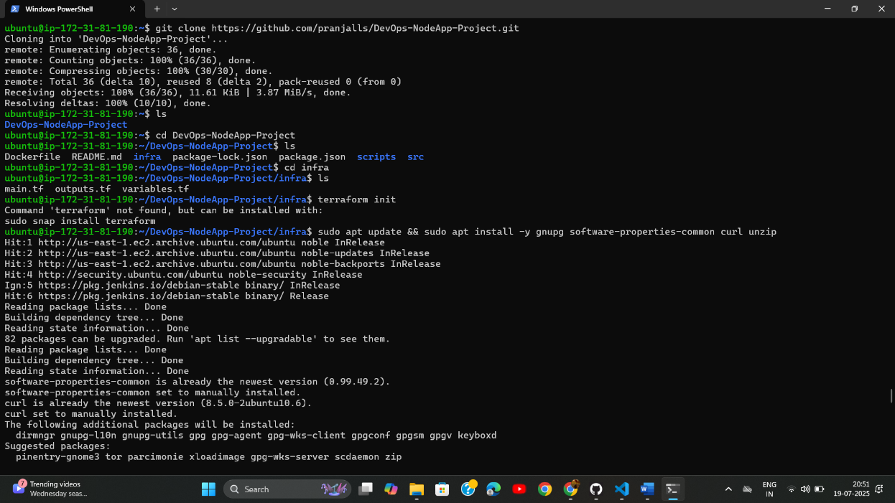terraform apply -var="key_name=devops-nodeapp" -auto-approve

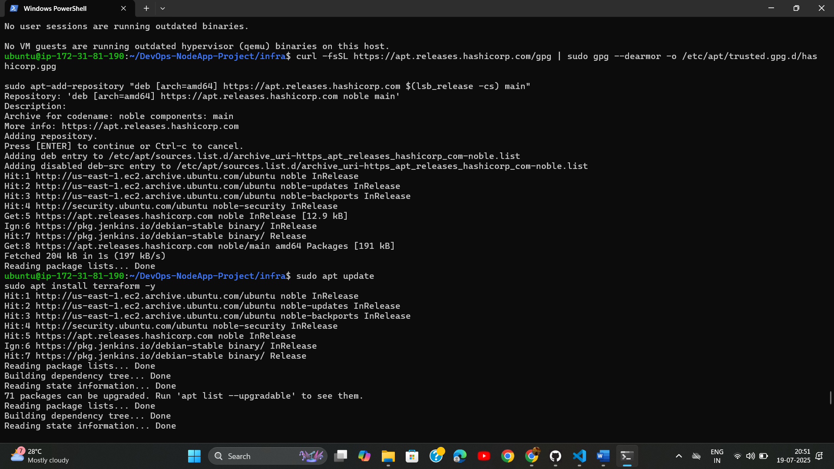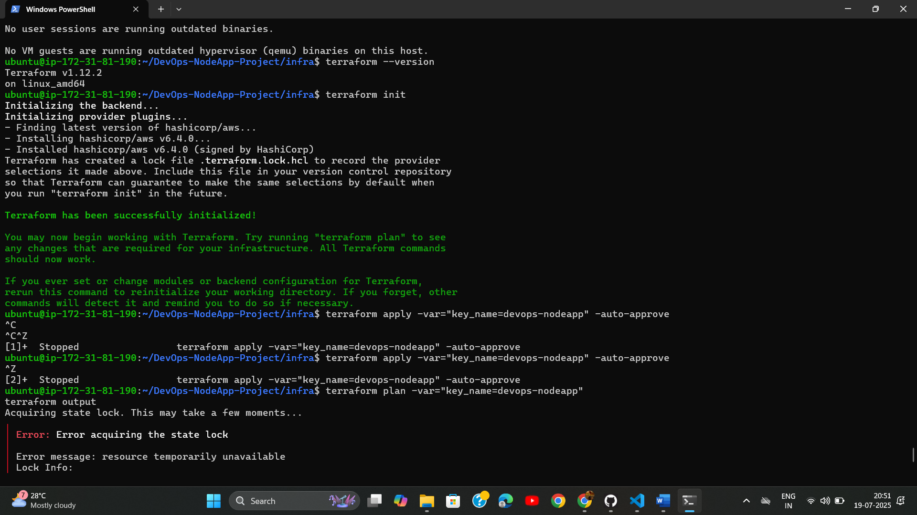

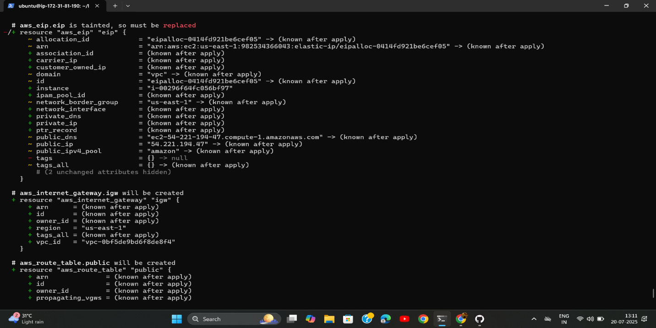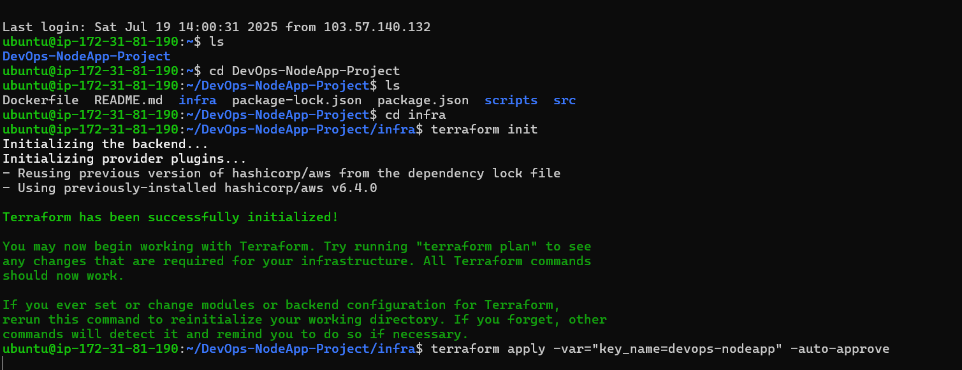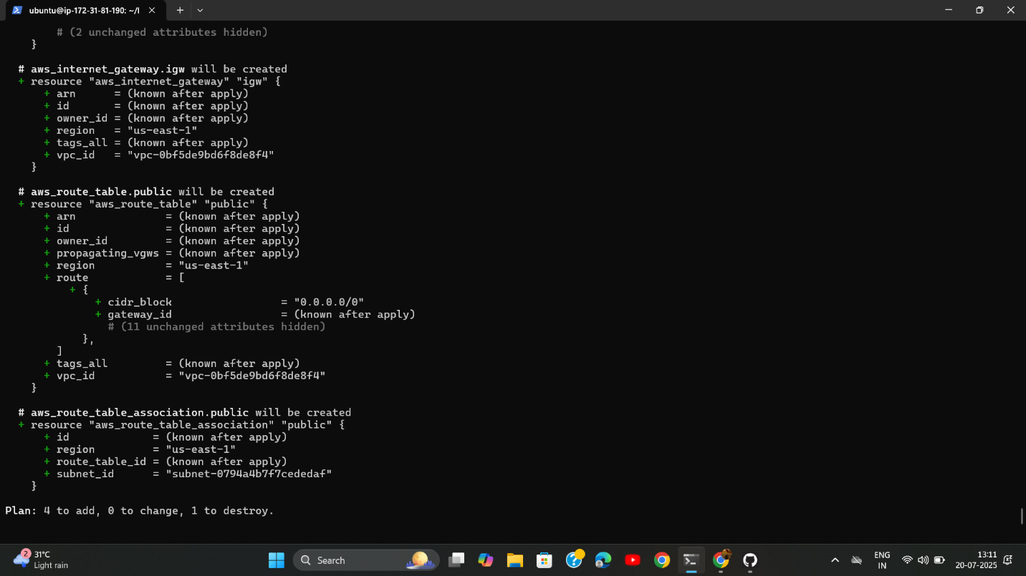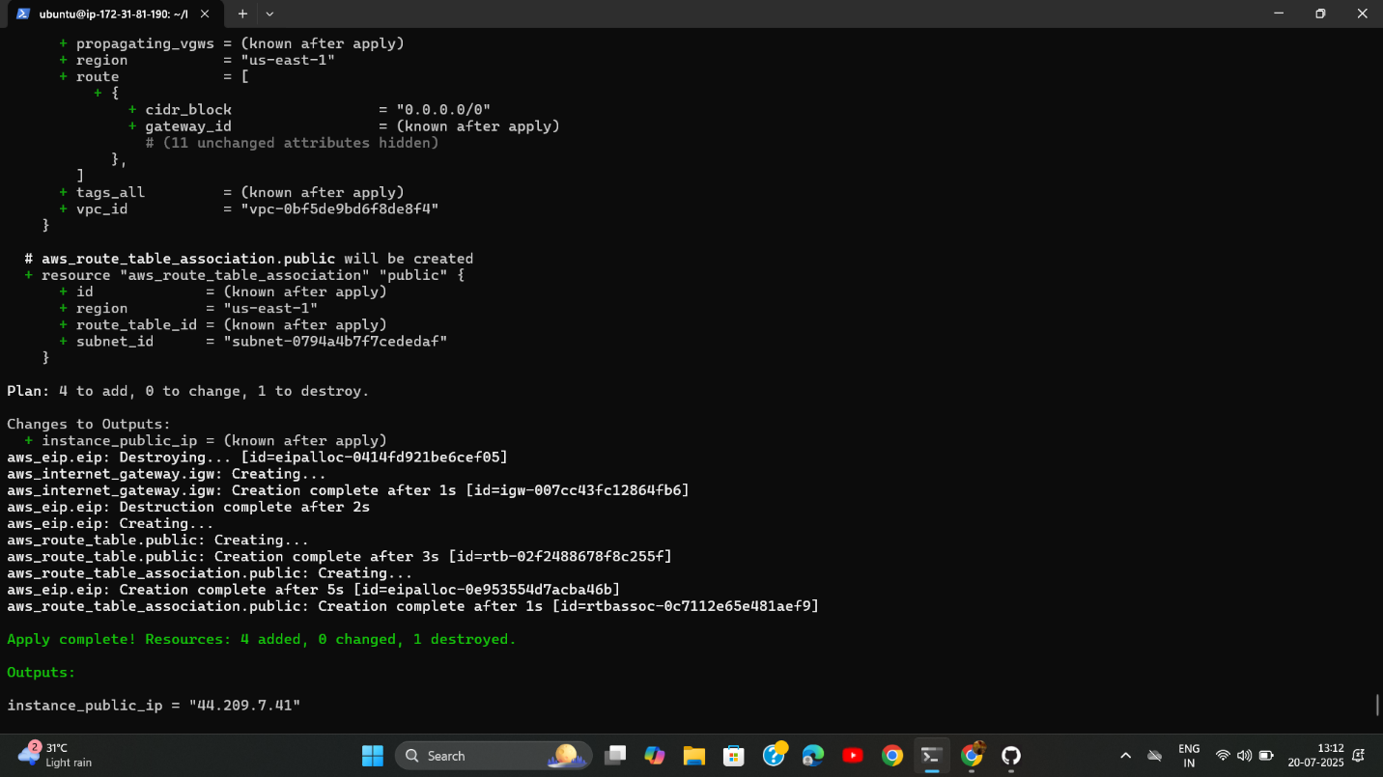

### 7. Ansible for Configuration Management

* Populate ansible/hosts.ini with the EC2 instance’s public IP
* In ansible/deploy.yml: Install Docker engine on the EC2 host
* Pull the Docker image published earlier
* Run the container mapping port 80→3000
* Verify success with: ansible-playbook -i hosts.ini deploy.yml

``

[web]  
<EC2_PUBLIC_IP> ansible_user=ubuntu ansible_ssh_private_key_file=~/.ssh/devops-nodeapp.pem

``

---  
- name: Deploy Node.js App to EC2  
 hosts: web  
 become: yes  
 tasks:  
 - name: Install Docker  
 apt:  
 name: docker.io  
 state: present  
 update_cache: yes  
  
 - name: Run Docker container  
 shell: |  
 docker pull ppranshinn0225/devops-node-app:latest  
 docker run -d -p 80:3000 ppranshinn0225/devops-node-app:latest

**Run:**

ansible-playbook -i ansible/hosts.ini ansible/deploy.yml

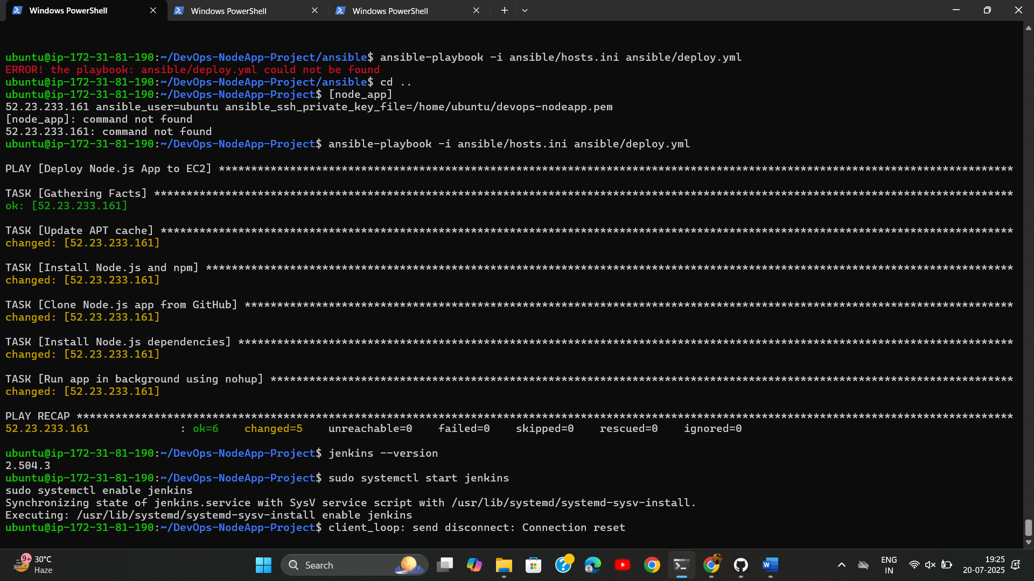

### 8. Jenkins CI/CD Pipeline

Install Jenkins → Configure Credentials (DockerHub, GitHub) → Create pipeline job.

**Jenkinsfile**

pipeline {  
 agent any  
 environment {  
 DOCKERHUB_CREDENTIALS = credentials('dockerhub')  
 IMAGE_NAME = 'ppranshinn0225/devops-node-app'  
 }  
 stages {  
 stage('Clean Workspace') {  
 steps {  
 cleanWs()  
 }  
 }  
 stage('Clone Repo') {  
 steps {  
 git branch: 'main', credentialsId: 'github-pat', url: 'https://github.com/pranjalls/DevOps-NodeApp-Project.git'  
 }  
 }  
 stage('Build Docker Image') {  
 steps {  
 sh 'docker build -t $IMAGE_NAME .'  
 }  
 }  
 stage('Push to Docker Hub') {  
 steps {  
 sh '''  
 echo $DOCKERHUB_CREDENTIALS_PSW | docker login -u $DOCKERHUB_CREDENTIALS_USR --password-stdin  
 docker push $IMAGE_NAME  
 '''  
 }  
 }  
 stage('Deploy with Ansible') {  
 steps {  
 sh 'ansible-playbook -i ansible/hosts.ini ansible/deploy.yml'  
 }  
 }  
 }  
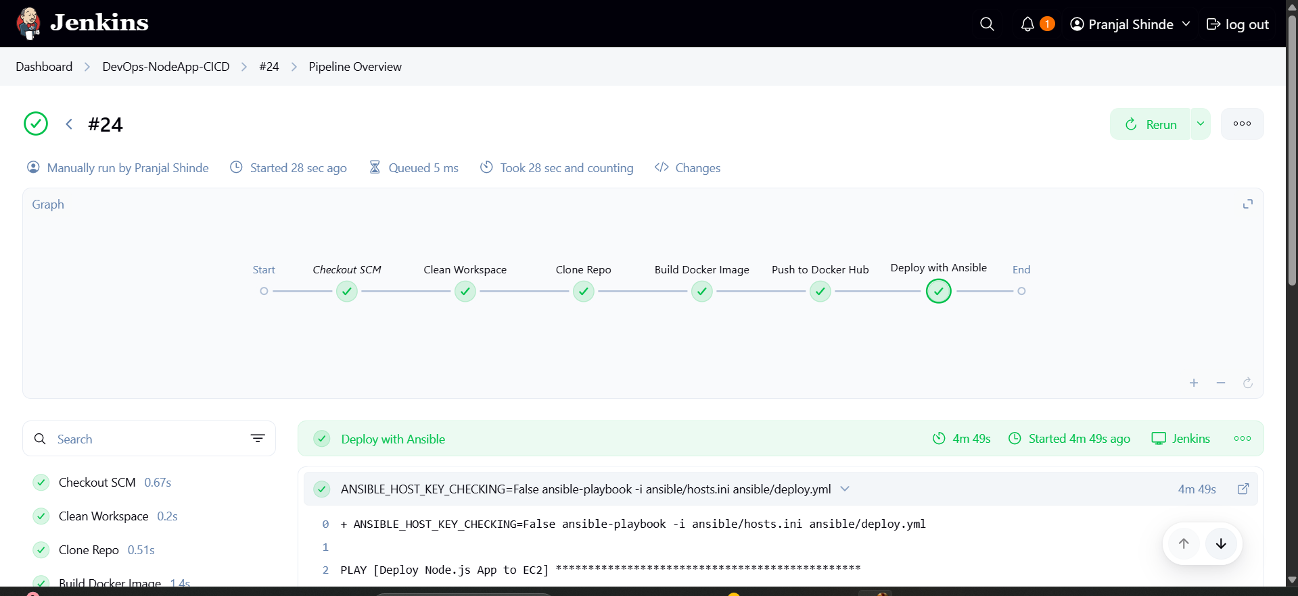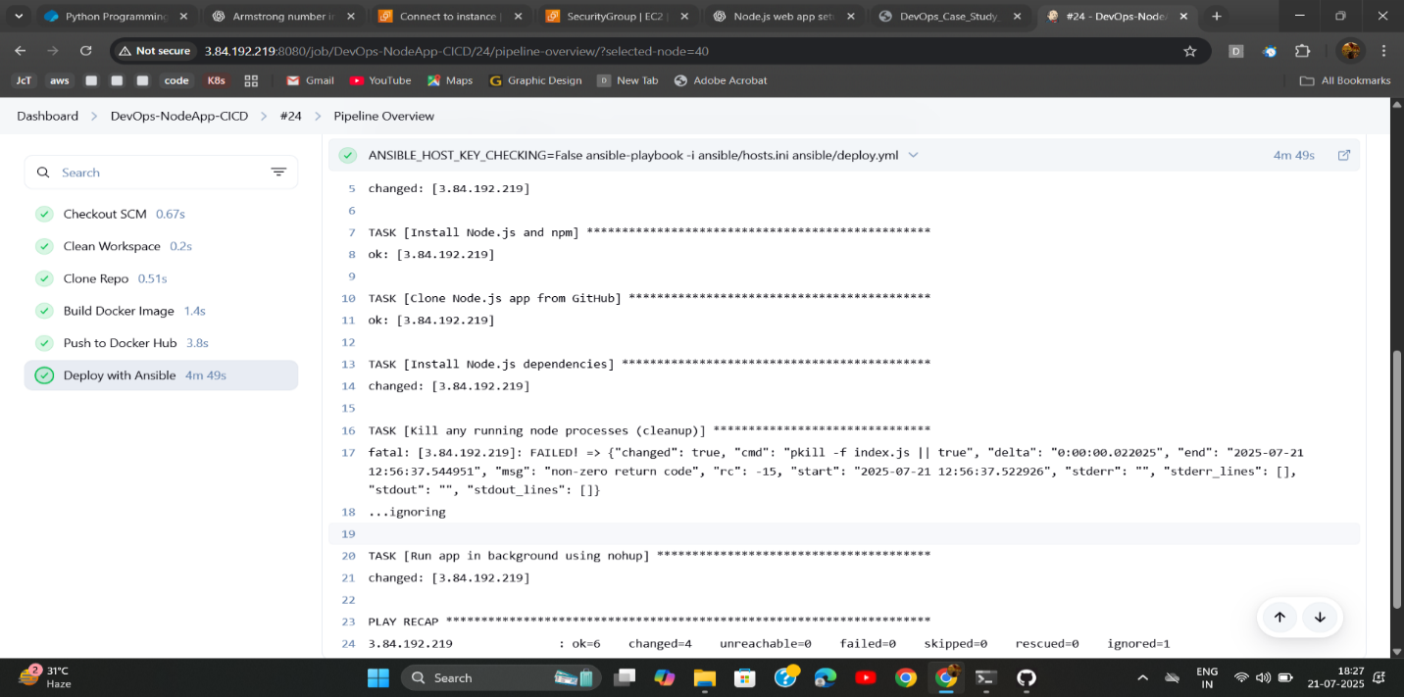}

Deployment of website🡪

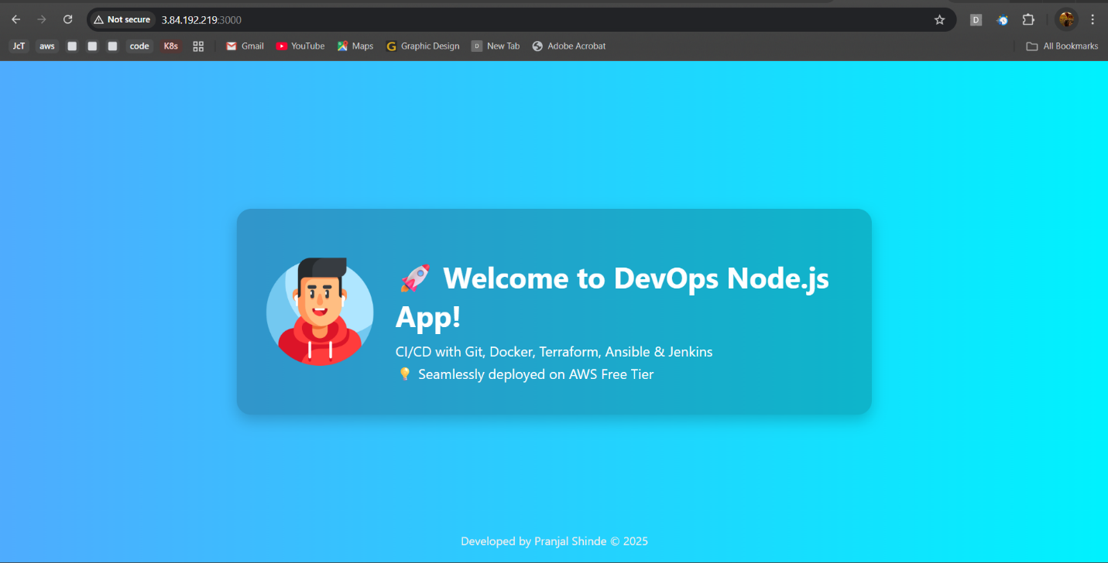

### 9. Shell Scripts

**cleanup.sh**

#!/usr/bin/env bash  
set -euo pipefail  
echo "Cleaning Docker..."  
docker image prune -f  
docker container prune -f docker network prune -f

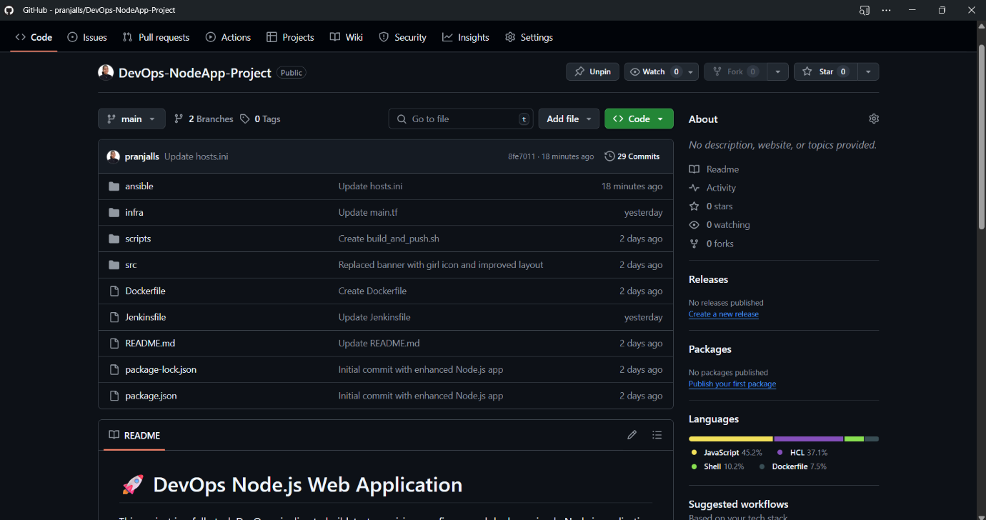  
dock

### 10. Common Errors & Troubleshooting

|  |  |  |
| --- | --- | --- |
| Issue | Cause | Solution |
| Docker permission denied | Jenkins user not in docker group | Add Jenkins user to docker group, restart Jenkins  sudo usermod -aG docker jenkins |
| SSH unreachable in Ansible | Wrong IP or key | Update hosts.ini with latest IP or Assign a static Elastic IP to your EC2 instance. |
| Docker login failed | Using password instead of access token | Use DockerHub Access Token |

### 

### 11. Architectural Diagram

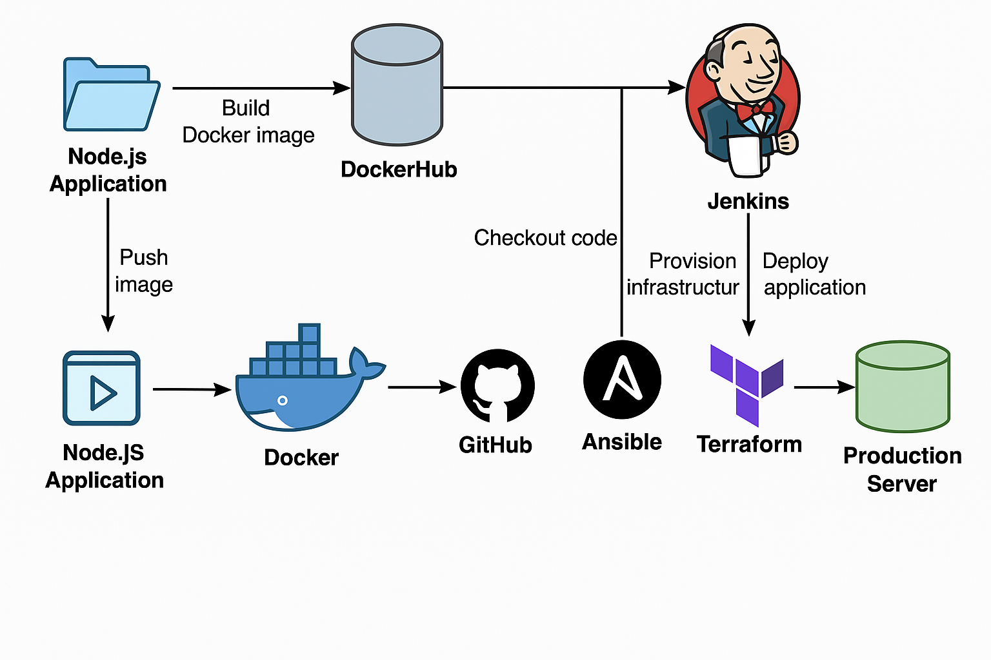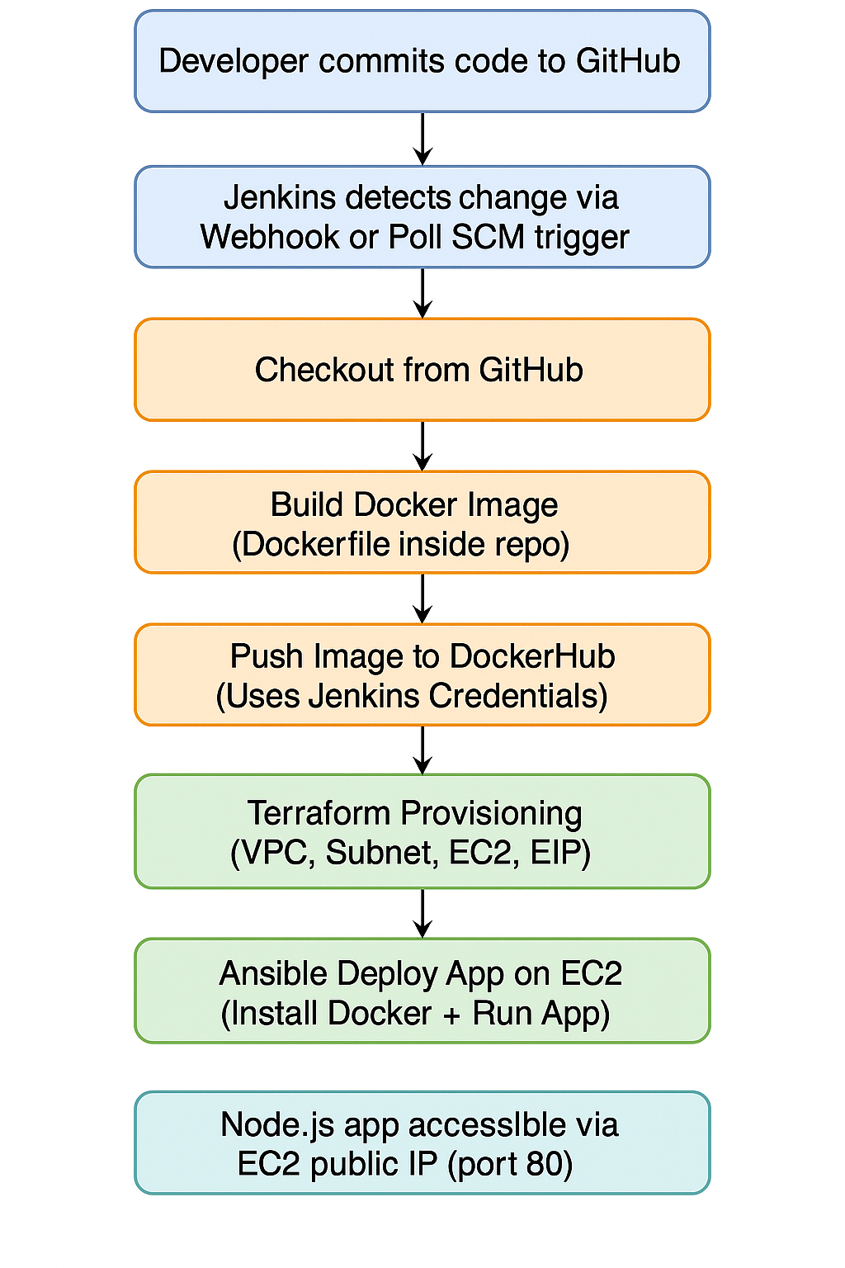

### 12. Final Report Summary

The project achieved end-to-end CI/CD for a Node.js application using:

* **Terraform** for infrastructure
* **Docker** for containerization
* **Ansible** for provisioning
* **Jenkins** for orchestration

This project demonstrated a full DevOps CI/CD pipeline from infrastructure provisioning to application deployment. Through the use of open-source tools and problem-solving at each stage, a fully automated pipeline was achieved.

*****************